Grade 6
Subject: English
Section A: Listening (40 marks)
Instructions:
- You will hear each recording twice.
- Listen carefully and answer the questions.
- For Q1–10, look at the pictures and choose the correct answer (A, B, C or D).
- For Q11–20, write one word/number/date/time in the blank.
- For Q21–25, choose the best option.
- For Q26–40, answer reasoning-based multiple-choice questions.
 | Part 1 (10 marks)
Transcript (Teacher/Audio):
- The woman is wearing a striped purple dress with white shoes. She's holding a black umbrella while walking her brown poodle. Which picture shows her?
- A boy is flying a yellow kite shaped like a diamond in the park. Two birds are flying higher than the kite. Which picture matches?
- In the library, a librarian is stacking books while a girl in a pink headphone reads at the table. A boy nearby is using a laptop. Identify the scene.
- At the beach, a man in blue shorts is building a sandcastle while a woman in a hat takes photos. A seagull is stealing their chips. Which picture shows this?
- The chef is chopping vegetables while wearing a tall white hat. On the stove, a pot is boiling but no oven is being used.
Select the correct image.
- In the garden, an old man waters sunflowers with a green can. A black cat watches from the fence behind him. Which picture matches?
- At the zoo, a zookeeper feeds bananas to a sitting elephant. Two monkeys are swinging in the background. Identify the correct scene.
- In the music class, a teacher plays guitar while two students clap. One student has drumsticks but isn't using them. Which picture shows this?
- At the market, a vendor sells oranges and apples. A customer in a yellow sari examines mangoes while holding a woven basket. Select the correct image.
- A postal worker rides a red bicycle past a bakery. A delivery truck is parked outside the pharmacy across the street. Which picture matches?
Student Task: For each question, circle A, B, C or D under the picture you hear.
-  | - 
-  | - 

Answer: A
Level of effort Low
Bloom’s Application
Concept Listening for Specific Information (colours, clothing, object)
Chapter Listening
2. | -  |  |  | - 
 | - 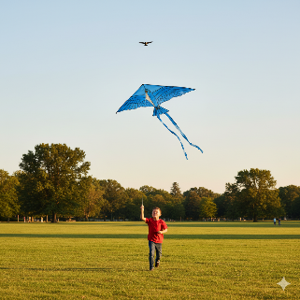 |  |  | - 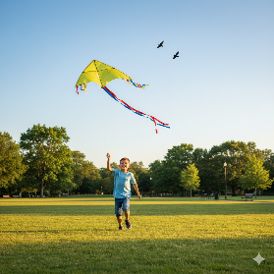
Answer: D
Level of effort Low
Bloom’s Application
Concept/skill Listening for Detail & Differentiation
Chapter Listening
3. | -  |  |  | - 
 | -  |  |  | - 
Answer: C
Level of effort Low
Bloom’s Application
Concept Listening for Specific Information
Chapter Listening
4. | - 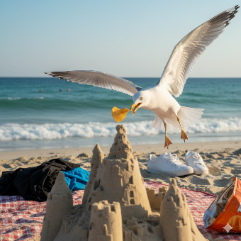 |  |  | - 
 | -  |  |  | - 
Answer: B
Level of effort Low
Bloom’s Application
Concept Listening for Specific Information
Chapter Listening
5. | -  |  |  | - 
 | -  |  |  | - 
Answer: D
Level of effort Low
Bloom’s Application
Concept Listening for Specific Information
Chapter Listening
6. | -  |  |  | - 
 | -  |  |  | - 
Answer: A
Level of effort Low
Bloom’s Application
Concept Listening for Detail
Chapter Listening
7. | -  |  |  | - 
 | -  |  |  | - 
Answer: B
Level of effort Low
Bloom’s Application
Concept Listening for Detail
Chapter Listening
8. | -  |  |  | - 
 | -  |  |  | - 
Answer: B
Level of effort Low
Bloom’s Application
Concept Listening for Detail
Chapter Listening
9. | -  |  |  | - 
 | -  |  |  | - 
Answer: D
Level of effort Low
Bloom’s Application
Concept Listening for Detail
Chapter Listening
10. | - 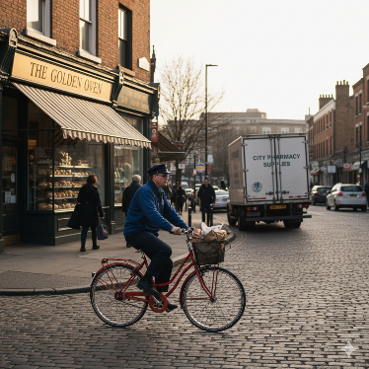 |  |  | - 
 | - 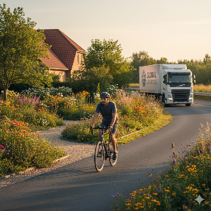 |  |  | - 
Answer: A
Level of effort Low
Bloom’s Application
Concept Listening for Detail
Chapter Listening
 | Part 2 (10 marks)
Transcript (Teacher/Audio):
- The school canteen closes at 2:30 in the afternoon.
- The new student's favorite colour is purple.
- Their science project is due on March 15th.
- A movie ticket for children costs 120 rupees.
- The history exam will cover Chapter 7.
- The football match starts at quarter past eleven.
- The librarian's office is on the third floor.
- They need two kilograms of flour for baking.
- The post office is opposite the bank.
- Her sister was born in August.

Student Task: Write the missing word, number, date, or time in the blank.
11. | The school canteen closes at ______ in the afternoon.
Answer: 2.30
Level of effort Moderate
Bloom’s Application
Concept Listening for specific detail
Chapter Listening
12. | The new student's favorite colour is ______.
Answer: purple
Level of effort Moderate
Bloom’s Application
Concept Listening for specific detail
Chapter Listening
13. | Their science project is due on ______ 15th.
Answer: March
Level of effort Moderate
Bloom’s Application
Concept Listening for specific detail
Chapter Listening
14. | A movie ticket for children costs ______ rupees.
Answer: 120
Level of effort Moderate
Bloom’s Application
Concept Listening for specific detail
Chapter Listening
15. | The history exam will cover Chapter ______.
Answer: 7
Level of effort Moderate
Bloom’s Application
Concept Listening for specific detail
Chapter Listening
16. | The football match starts at ______ past eleven.
Answer: quarter
Level of effort Moderate
Bloom’s Application
Concept Listening for specific detail
Chapter Listening
17. | The librarian's office is on the ______ floor.
Answer: third
Level of effort Moderate
Bloom’s Application
Concept Listening for specific detail
Chapter Listening
18. | They need ______ kilograms of flour for baking.
Answer: two
Level of effort Moderate
Bloom’s Application
Concept Listening for specific detail
Chapter Listening
19. | The post office is opposite the ______.
Answer: bank
Level of effort Moderate
Bloom’s Application
Concept Listening for specific detail
Chapter Listening
20. | Her sister was born in ______.
Answer: August
Level of effort Moderate
Bloom’s Application
Concept Listening for specific detail
Chapter Listening
 | Part 3 (5 marks)
Man: "Should we meet at 5:00 or 5:30 for the concert?"
Woman: "Let's meet at 5:15—I need extra time to park."
When will they meet?
 | When will they meet?
- 5.00
- 5.15
- 5.30
- 5.18
Answer: B
Level of effort Moderate
Bloom’s Application
Concept Listening for specific detail
Chapter Listening
Teacher: "Is your science project about plants or animals?"
Student: "It’s actually about ocean pollution."
 | What is the project about?
A. Plants
B. Animals
C. Ocean pollution
D. Air quality
Answer: C
Level of effort Moderate
Bloom’s Application
Concept Listening for specific detail
Chapter Listening
Girl: "Should I wear my red dress or blue jeans today?"
Mother: "The blue jeans look better for hiking."
 | What did mother recommend?
A. Red dress
B. Blue jeans
C. Formal suit
D. Skirt
Answer: B
Level of effort Moderate
Bloom’s Application
Concept Listening for specific detail
Chapter Listening
Woman: "Did you finish the assignment on the sofa or at the desk?"
Boy: "I did it at the kitchen table."
 | Where was the assignment done?
A. Sofa
B. Desk
C. Kitchen table
D. Bed
Answer: C
Level of effort Moderate
Bloom’s Application
Concept Listening for specific detail
Chapter Listening
Man: "Is your birthday in July like your sister’s?"
Girl: "No, mine is in August—right before school starts."
 | When is the girl’s birthday?
A. July
B. August
C. September
D. June
Answer: B
Level of effort Moderate
Bloom’s Application
Concept Listening for specific detail
Chapter Listening
 | Part 4 (15 marks)
 | "The museum tour group took the stairs instead of the elevator. The guide explained the elevator was under repair."
 | Why didn’t they use the elevator?
A. Too crowded
B. Under repair
C. Energy saving
D. Safety drill
Answer: B
Level of effort High
Bloom’s Application
Concept Listening for specific detail
Chapter Listening
 | "Lucas bought a red bicycle helmet. His old one cracked during a fall last week."
 | Why did Lucas get a new helmet?
A. Colour preference
B. Old one cracked
C. Birthday gift
D. School rule
Answer: B
Level of effort High
Bloom’s Application
Concept Listening for specific detail
Chapter Listening
 | "The soccer team practiced indoors. Heavy rain made the field too muddy to use."
 | Why did they practice indoors?
A. Muddy field
B. Coach’s order
C. New strategy
D. Player injury
Answer: A
Level of effort High
Bloom’s Application
Concept Listening for specific detail
Chapter Listening
 | "Priya added extra sugar to the lemonade. Her brother mentioned it was too sour yesterday."
 | Why did Priya add more sugar?
A. Brother’s complaint
B. Recipe instruction
C. Sweet tooth
D. Health advice
Answer: A
Level of effort High
Bloom’s Application
Concept Listening for specific detail
Chapter Listening
 | "The concert tickets sold out quickly. The band had won a music award last month."
 | Why were tickets hard to get?
A. Small venue
B. Band’s recent award
C. Low price
D. Technical error
Answer: B
Level of effort High
Bloom’s Application
Concept Listening for specific detail
Chapter Listening
 | "Nina wore hiking boots to the forest. The trail was known for rocky paths and uneven ground."
 | Why did Nina choose hiking boots?
A. Rocky trail
B. Fashion trend
C. Gift from friend
D. Cold weather
Answer: A
Level of effort High
Bloom’s Application
Concept Listening for specific detail
Chapter Listening
 | "The bakery ran out of chocolate croissants by 9 a.m. A food blogger had praised them online."
 | Why were croissants sold out?
A. Limited stock
B. Blogger’s review
C. Discount offer
D. Holiday demand
Answer: B
Level of effort High
Bloom’s Application
Concept Listening for specific detail
Chapter Listening
 | "Ravi took a taxi instead of the subway. The train workers were on strike all morning."
 | Why did Ravi use a taxi?
A. Subway strike
B. Faster route
C. Lost wallet
D. Bad weather
Answer: A
Level of effort High
Bloom’s Application
Concept Listening for specific detail
Chapter Listening
 | "The art class used charcoal instead of paint. The classroom’s water supply was interrupted."
 | Why did they use charcoal?
A. No water
B. Teacher’s preference
C. Cheaper material
D. Student request
Answer: A
Level of effort High
Bloom’s Application
Concept Listening for specific detail
Chapter Listening
 | "Zoe bought earplugs before her flight. She wanted to sleep during the loud engine noise."
 | Why did Zoe get earplugs?
A. Flight noise
B. Ear infection
C. Gift for friend
D. Fashion accessory
Answer: A
Level of effort High
Bloom’s Application
Concept Listening for specific detail
Chapter Listening
 | "The picnic was moved to the community hall. Forecasters predicted thunderstorms all afternoon."
 | Why change the picnic location?
A. Thunderstorm forecast
B. Better facilities
C. Animal invasion
D. Food shortage
Answer: A
Level of effort High
Bloom’s Application
Concept Listening for specific detail
Chapter Listening
 | "The math test was rescheduled to Friday. A fire drill interrupted the original Wednesday slot."
 | Why was the test moved?
A. Fire drill
B. Teacher’s absence
C. Student protests
D. Syllabus change
Answer: A
Level of effort High
Bloom’s Application
Concept Listening for specific detail
Chapter Listening
 | "Aisha watered her plants twice daily. The heatwave caused soil to dry unusually fast."
 | Why did Aisha water plants more?
A. Heatwave drying soil
B. New plant type
C. Broken sprinkler
D. Gardening contest
Answer: A
Level of effort High
Bloom’s Application
Concept Listening for specific detail
Chapter Listening
 | "The flight to Chicago was delayed by two hours. The pilot announced that heavy fog made takeoff unsafe."
 | Why was the flight delayed?
A. Technical issues
B. Heavy fog
C. Crew shortage
D. Air traffic
Answer: B
Level of effort High
Bloom’s Application
Concept Listening for specific detail
Chapter Listening
 | "Emma always studies at the rooftop garden. She says the lack of noise helps her concentrate."
 | Why does Emma prefer the rooftop garden?
A. Quiet environment
B. Nice view
C. Fresh air
D. Good lighting
Answer: A
Level of effort High
Bloom’s Application
Concept Listening for specific detail
Chapter Listening
Section B: Speaking (40 Marks)
Instructions for Examiner:
- This test has three parts.
- Use the prompts and pictures provided.
- Encourage students to speak in full sentences.
- Award marks based on fluency, vocabulary, accuracy and ability to communicate ideas.
Part 1 – Introduction (10 marks)

Task: The student reads the question prompts on the screen and answers the simple personal questions.
Sample Questions:
- What is your name?
- How old are you?
- Where do you live?
- What is your favorite subject in school?
- How do you usually travel to school?
- What meal do you enjoy cooking or eating most?
Student Task: Answer in 2–3 sentences each, not just one word.
Time limit: 5 minutes
Level of effort High
Bloom’s Create
Concept Self-Introduction
Chapter Speaking
Part 2 – Picture-based Description (15 marks)

Task: The student views the given picture and describes it.
Time limit: 5 minutes
 | 
Level of effort High
Bloom’s create
Concept Picture based description
Chapter Speaking
Part 3 – Opinion Questions (15 marks)

Task: The student reads the statement on the screen and gives their opinion on the topic. Choose any one.
Time limit: 5 minutes
Schools should replace paper textbooks with tablets for all students.
→ Do you agree? Why or why not?
Climate change education should be mandatory in all schools.
→ Do you agree? Why or why not?
Level of effort High
Bloom’s Application
Concept Opinion Based
Chapter Speaking
 | Section C: Reading
 | Part 1- (10 marks)
 | Choose the correct answer for questions 1 to 10.
Sign at Gym
"Members must wipe equipment after use. Towels provided at reception."
This notice means members should:
A. bring their own towels
B. avoid using equipment
C. clean machines after exercising
D. only use equipment in the morning
Answer: C
Level of effort low
Bloom’s recall
Concept Interpreting Notices / Instructions
Chapter Reading
Bus Stop Notice
"Route 42 suspended during road repairs. Use temporary stop 200m ahead."
Passengers should:
A. wait longer at this stop
B. walk to the new stop
C. take a different route
D. complain to the driver
Answer: B
Level of effort low
Bloom’s recall
Concept Interpreting Notices / Instructions
Chapter Reading
Restaurant Menu
"Gluten-free options marked with GF. Ask staff about allergens."
Customers learn that:
A. all dishes are gluten-free
B. special markings indicate GF items
C. staff will not discuss ingredients
D. extra charges apply for GF meals
Answer: B
Level of effort low
Bloom’s recall
Concept Interpreting Notices / Instructions
Chapter Reading
School Noticeboard
"Art exhibition moved to Auditorium. Original venue unavailable due to repairs."
Students should go to the:
A. library
B. auditorium
C. classroom
D. sports hall
Answer: B
Level of effort low
Bloom’s recall
Concept Interpreting Notices / Instructions
Chapter Reading
Parking Sign
"Reserved for electric vehicles only. Others will be towed."
This means:
A. All cars can park here briefly
B. Only EVs may use this space
C. Towing service available here
D. Parking free for hybrid cars
Answer: B
Level of effort low
Bloom’s recall
Concept Interpreting Notices / Instructions
Chapter Reading
Supermarket Poster
"Return faulty items within 7 days with receipt for full refund."
Customers must:
A. keep damaged goods
B. show proof of purchase
C. wait 14 days for returns
D. accept store credit only
Answer: B
Level of effort low
Bloom’s recall
Concept Interpreting Notices / Instructions
Chapter Reading
Online Exam Instructions
"Webcam must remain on throughout the test. Closing it voids your attempt."
Students must:
A. disable their microphone
B. keep camera operational
C. take breaks frequently
D. hide their screen
Answer: B
Level of effort low
Bloom’s recall
Concept Interpreting Notices / Instructions
Chapter Reading
Airport Announcement
"Liquids over 100ml not permitted in carry-on luggage. Place them in checked bags."
Travelers should:
A. pack large bottles in suitcase
B. carry all liquids openly
C. discard containers over 100ml
D. buy liquids after security
Answer: A
Level of effort low
Bloom’s recall
Concept Interpreting Notices / Instructions
Chapter Reading
Cinema Poster
"Children under 15 must be accompanied by an adult for horror films."
This rule applies to:
A. all movie genres
B. cartoon screenings
C. scary movies
D. morning shows
Answer: C
Level of effort low
Bloom’s recall
Concept Interpreting Notices / Instructions
Chapter Reading
"Team lunch postponed to Friday. Original Wednesday plan cancelled due to client meeting."
The new lunch date is:
A. Tuesday
B. Wednesday
C. Thursday
D. Friday
Answer: D
Level of effort low
Bloom’s recall
Concept Interpreting Notices / Instructions
Chapter Reading
Part 2- 10 Marks
Questions 11-20
For each question, choose the correct answer.
Young Photographers’ Journals
Three photography enthusiasts share their experiences:
Alex
I started documenting street art in my city last year. My blog features photos of murals and interviews with artists. I always note the exact locations and materials used (like spray paint vs. stencils) because followers want to visit these spots. My brother helps me edit videos showing the creation process. The most rewarding part is discovering hidden artworks through readers’ tips.
Priya
My focus is wildlife photography. I post weekly from nature reserves, explaining how I capture animals without disturbing them. At first, I hesitated to share my work, but a teacher urged me to try. My “bird nesting” series went viral! I’ve started adding short audio clips of animal sounds, which viewers love. This hobby combines my passion for nature and tech skills.
Omar
I use my blog as a visual diary of architectural wonders. Each post compares old and new buildings in my neighborhood. What began as a school project now has international readers who suggest historical facts about structures. When exams pile up, I post less frequently, but I always return – this blog is my creative anchor.

Who provides technical assistance to the blogger?
A. Alex’s brother
B. Priya
C. Omar
D. Alex

Answer: A
Level of effort low
Bloom’s recall
Concept Reading Blog
Chapter Reading

Which blog includes audio elements?
A. Alex’s
B. Priya’s
C. Omar’s

D. Priya and Alex’s

Answer: B
Level of effort low
Bloom’s recall
Concept Reading Blog
Chapter Reading

Who started blogging for a school-related reason?
A. Alex
B. Priya
C. Omar
D. All three

Answer: C
Level of effort low
Bloom’s recall
Concept Reading Blog

Chapter Reading

Which blogger mentions audience-sourced information?
A. Alex
B. Priya
C. Omar
D. Alex and Omar

Answer: D
Level of effort low
Bloom’s recall
Concept Reading Blog

Chapter Reading

Who overcame initial doubts about sharing work?
A. Alex
B. Priya
C. Omar
D. Priya and Omar

Answer: B
Level of effort low
Bloom’s recall
Concept Reading Blog

Chapter Reading

What do Alex’s posts always include about artworks?
A. Artist interviews
B. Location details
C. Video edits
D. Historical facts

Answer: B
Level of effort low
Bloom’s recall
Concept Reading Blog

Chapter Reading

Who balances blogging with academic pressures?
A. Alex
B. Priya
C. Omar
D. All three

Answer: C
Level of effort low
Bloom’s recall
Concept Reading Blog

Chapter Reading

Which blogger’s content went viral?
A. Alex’s mural videos
B. Priya’s bird series
C. Omar’s school project
D. None

Answer: B
Level of effort low
Bloom’s recall
Concept Reading Blog

Chapter Reading

What technical skill does Priya combine with nature photography?
A. Audio editing
B. Video editing
C. 3D modeling
D. Graphic design

Answer: A
Level of effort low
Bloom’s recall
Concept Reading Blog

Chapter Reading

Which blog focuses on urban development changes?
A. Alex’s
B. Priya’s
C. Omar’s
D. All three

Answer: C
Level of effort low
Bloom’s recall
Concept Reading Blog

Chapter Reading
 | Part 3 (15Marks)
The Green Earth Initiative
In 2024, a team of scientists and activists from Brazil, Japan and Kenya launched the Green Earth Initiative to combat deforestation. Dr. Amina Mwangi, a Kenyan ecologist, leads the project, which uses AI-powered drones to monitor rainforests in the Amazon and Congo Basin.
The initiative partners with Indigenous communities like the Yanomami tribe in Brazil to plant 10 million trees annually. In Japan, students from Tokyo University developed an app called EcoTrack to crowdsource deforestation alerts. "Global problems need global solutions," says Dr. Mwangi.
A breakthrough came in March 2025 when the team discovered a new carbon-absorbing moss species in Mount Kenya. This moss, named Bryum viridis, can store 20% more CO₂ than ordinary plants. The project now expands to Indonesia’s peatlands, funded by a UN grant.
Who leads the Green Earth Initiative?
A. A Yanomami elder
B. Dr. Amina Mwangi
C. A Tokyo University student
D. A UN official
Answer: B
Level of effort low
Bloom’s recall
Concept Reading Passage
Chapter Reading
What technology do they use to monitor forests?
A. Satellite imagery
B. AI-powered drones
C. Ground sensors
D. Human patrols
Answer: B
Level of effort low
Bloom’s recall
Concept Reading Passage
Chapter Reading
Which community partners with the initiative in Brazil?
A. Maasai
B. Yanomami
C. Inuit
D. Sami
Answer: B
Level of effort low
Bloom’s recall
Concept Reading Passage
Chapter Reading
What unique discovery did the team make in 2025?
A. A renewable energy source
B. A carbon-absorbing moss
C. A new rainforest animal
D. A water purification method
Answer: B
Level of effort low
Bloom’s recall
Concept Reading Passage
Chapter Reading
Which country’s peatlands are part of the expanded project?
A. Indonesia
B. Canada
C. Russia
D. Australia
Answer: A
Level of effort low
Bloom’s recall
Concept Reading Passage
Chapter Reading
Questions 26–30
For each question, choose the correct answer.
The Amazon Rainforest: Earth’s Lungs
The Amazon Rainforest, spanning nine countries in South America, covers over 5.5 million square kilometers. It produces 20% of the world’s oxygen and houses 10% of all known species, including jaguars, pink river dolphins and 16,000 tree varieties. Indigenous tribes like the Yanomami have lived here sustainably for millennia.
Ecotourism has grown rapidly, with visitors hiking, birdwatching, or exploring the Amazon River. Biologists study its biodiversity, calling it a “living laboratory” for climate research.
Sadly, deforestation threatens the Amazon. Illegal logging, cattle ranching and wildfires destroy 20,000 square kilometers annually. This disrupts rainfall patterns and releases stored carbon, worsening global warming.
Conservation groups like WWF and local governments now enforce stricter laws. Reforestation projects and “carbon credit” programs aim to balance economic needs with ecological preservation.
How much of the world’s oxygen does the Amazon produce?
A. 5%
B. 10%
C. 20%
D. 30%
Answer: C
Level of effort low
Bloom’s recall
Concept Reading Passage
Chapter Reading
Which activity is NOT mentioned as part of Amazon ecotourism?
A. Birdwatching
B. Hiking
C. Scuba diving
D. River exploration
Answer: C
Level of effort low
Bloom’s recall
Concept Reading Passage
Chapter Reading
What annual deforestation rate is stated in the text?
A. 5,000 sq km
B. 10,000 sq km
C. 20,000 sq km
D. 50,000 sq km
Answer: C
Level of effort low
Bloom’s recall
Concept Reading Passage
Chapter Reading
Which group is directly involved in Amazon conservation?
A. NASA
B. WWF
C. UNESCO
D. UNICEF
Answer: B
Level of effort low
Bloom’s recall
Concept Reading Passage
Chapter Reading
What do “carbon credit” programs aim to balance?
A. Tourism and logging
B. Economic needs and ecology
C. Indigenous rights and mining
D. Rainfall patterns and wildfires
Answer: B
Level of effort low
Bloom’s recall
Concept Reading Passage
Chapter Reading
Answer the given questions (31-35) in approx. 1-2 sentences.
The Solar Power Revolution
Solar energy has emerged as a leading renewable power source, with global capacity doubling every 3–4 years. Unlike fossil fuels, solar panels generate electricity without emissions, reducing reliance on coal and oil. Countries like Germany and China now derive over 10% of their energy from solar farms and rooftop installations.
Governments incentivise solar adoption through tax rebates and "net metering" policies, allowing households to sell excess energy back to grids. Innovations like perovskite solar cells promise higher efficiency at lower costs, with companies like Tesla integrating solar roofs into mainstream housing.
Challenges persist. Solar farms require vast land areas, raising concerns about habitat disruption. Energy storage remains problematic—batteries struggle to retain power during cloudy periods. In developing nations, upfront costs and lack of infrastructure hinder adoption despite abundant sunlight.
Germany’s Energiewende (energy transition) demonstrates success: 50% of its electricity now comes from renewables, including solar. Critics argue this transition relies heavily on subsidies, but proponents highlight long-term savings and job creation in green industries.
Experts predict solar could supply 30% of global energy by 2040 if storage technology improves. Combined with wind and hydropower, it offers a viable path to decarbonisation.
31. Why might governments prioritise solar energy subsidies over direct fossil fuel regulation?
Governments likely subsidise solar energy to encourage voluntary adoption while avoiding political resistance from fossil fuel industries. This approach balances environmental goals with economic stability during the transition.
32. What does Germany’s Energiewende reveal about public attitudes toward renewable energy?
Germany’s success suggests public support for renewables grows when policies align with economic benefits (e.g., job creation) and energy independence, even if initial costs are high.
33. How could improved battery technology indirectly address habitat disruption from solar farms?
Better storage would reduce the need for large solar farms by maximising energy output from smaller installations (e.g., rooftops), minimising land-use conflicts with ecosystems.
34. Why might solar adoption in developing nations lag despite abundant sunlight?
High upfront costs, lack of financing options and unreliable grids create barriers, even when sunlight is plentiful. This highlights the need for international funding and localised infrastructure plans.
35. “Solar alone cannot decarbonise economies.” Do you agree? Justify with reasoning.
Agree. Solar’s intermittency requires complementary technologies (wind, nuclear) and grid modernisation. Industrial sectors like steel production also need alternative solutions (e.g., hydrogen) to achieve full decarbonisation.
Level of effort moderate
Bloom’s analysis
Concept Reading Passage
Chapter Reading
 | Part 4 (10 Marks)

Questions 36–40
For each question, choose the correct answer.
Alan Turing: The Codebreaker Who Shaped the Future
Alan Turing, born in 1912 in England, was a mathematician and computer scientist. During World War II, he played a crucial role in breaking German codes, which 36________ the war’s outcome. His work on the Enigma machine saved countless lives, but his contributions remained classified for decades.
Turing also laid the foundation for modern computing with his concept of the Turing Machine, a theoretical model that 37________ how computers process information. Despite his genius, he faced persecution for being gay, which was illegal in Britain at the time. In 1952, he was arrested and chemically castrated, yet he 38________ his research until his tragic death in 1954.
Today, Turing is celebrated as a pioneer of artificial intelligence. His legacy 39________ debates about ethics in technology and LGBTQ+ rights. Many argue that his persecution 40________ scientific progress for years, as his later ideas were never fully explored.
36.
A) shorten
B) shortened
C) shortening
D) shortens
37.
A) redefined
B) redefines
C) redefining
D) redefine
38.
A) continues
B) continued
C) continuing
D) continue
39.
A) fuels
B) fueled
C) fueling
D) fuel
40.
A) delayed
B) delays
C) delaying
D) delay

Answers:

36. shortened

37. redefines

38. continued

39. fuels

40. delayed
Level of effort moderate
Bloom’s application
Concept Cloze passage

Chapter Reading

Questions 41–45
For each question, choose the correct answer.
Rosalind Franklin: The Overlooked Pioneer of DNA
Rosalind Franklin, born in 1920 in London, was a chemist whose work 41________ the discovery of DNA’s double-helix structure. Using X-ray crystallography, she captured Photo 51, a critical image that 42________ crucial clues about DNA’s shape. However, her contributions were often overshadowed by her male colleagues at the time.
Despite her groundbreaking research, Franklin 43________ full recognition during her lifetime. Her data was shared without her consent and the Nobel Prize for DNA’s discovery was awarded to Watson, Crick and Wilkins in 1962, four years after her death. Today, historians and scientists 44________ her role as essential to one of biology’s greatest breakthroughs.
Franklin’s story 45________ the importance of ethical collaboration and the need to acknowledge underrepresented voices in science.
41.
A) enabled
B) enables
C) enabling
D) enable
42.
A) revealed
B) reveals
C) revealing
D) reveal
43.
A) never received
B) never receives
C) had never received
D) has never received
44.
A) argue
B) argues
C) argued
D) arguing
45.
A) highlights
B) highlighted
C) highlighting
D) highlight

Answers
- enabled
- revealed
- never received
- argue
- highlights
Level of effort moderate
Bloom’s application
Concept Cloze passage
Chapter Reading
 | Part 5 (10Marks)

Questions 46–50
For each question, write the correct answer. Write one word for each gap.
 | grazing | silently | wildlife |  | thrilling | patient
For each question, choose the most contextually appropriate word.
From: Clara
To: Jake
I just returned from a wildlife photography trip in Kenya! The experience was absolutely 46________ – I saw lions, elephants and even a leopard hunting at dawn.
On the first day, our guide taught us to move 47________ through the bush to avoid startling animals. The most challenging part was staying 48________ during long waits for the perfect shot.
One morning, we witnessed a herd of zebras 49________ near a watering hole. Their stripes created a mesmerising pattern against the golden savanna.
The trip reminded me how fragile ecosystems are. I’ve decided to donate 10% of my photography earnings to 50________ conservation efforts.
Can’t wait to show you the photos!
Best,
Clara

Answers

46. thrilling

47. silently

48. patient
49. grazing

50. wildlife

Level of effort moderate
Bloom’s application
Concept Cloze passage
Chapter Reading

Questions 51–55

For each question, write the correct answer. Write one word for each gap.
 | agreement | misplaced | hub |  | via | Wellness
From: Campus Accommodation Services
To: Incoming Residents
Dear Students,
Welcome to your new home on campus! To ensure a smooth transition, we’ve organised a Residence Welcome Workshop on Wednesday at 2:30 p.m. in the Student 51 ________. This session will cover safety protocols, laundry systems and shared kitchen guidelines.
Please bring your signed rental 52 ________ and a digital/physical copy of your health insurance. A campus tour will follow the workshop, where you’ll locate key buildings like the 53 ________ Centre and 24-hour study zones.
For urgent inquiries, reach us 54 ________ phone at +44-XXXX-XXXXXX. Kindly label all personal items clearly, as the university cannot be responsible for 55 ________ belongings.
We’re excited to help you start this new chapter!
Best regards,
Campus Accommodation Team

Answers
51. hub
52. Agreement
53. Wellness
54. Via
55. misplaced
Level of effort moderate
Bloom’s application
Concept Cloze passage
Chapter Reading
 | Section D: Writing
 | Guided Writing-Email (5M)
1. | You want to organise a weekend hiking trip with your colleague, Priya.  Write an email to Priya in under 100 words. Include:  - Invitation for Saturday/Sunday hiking  - Mention the trail location (e.g., Green Valley Trail)  - Suggest what to bring (e.g., water, snacks)
Answer:
Level of effort high
Bloom’s create
Concept/Skill Writing
Chapter Email writing
Criteria | Excellent (3 marks) | Satisfactory (2 marks) | Needs Improvement (1 mark)
Content / Task Completion | All required points included: invitation, location, travel details, clear purpose | Most points included; minor details missing or unclear | Key points missing; purpose unclear
Organisation / Coherence | Ideas well organised; email flows logically with paragraphs | Ideas mostly organised; some abrupt jumps | Poorly organised; ideas scattered
Language / Vocabulary | Appropriate friendly tone, varied vocabulary, correct word choice | Mostly appropriate tone; limited vocabulary, minor errors | Tone inappropriate; poor vocabulary; frequent errors
Grammar / Sentence Structure | Correct grammar, punctuation and sentence structure throughout | Minor grammar/punctuation errors; meaning still clear | Frequent grammar/punctuation errors; meaning affected
Salutation & Closing | Correct and appropriate salutation and closing used | Salutation or closing slightly inappropriate | Salutation and closing missing or incorrect

2. | Look at the picture. Describe in 100 words or more what you see in the picture.
 | 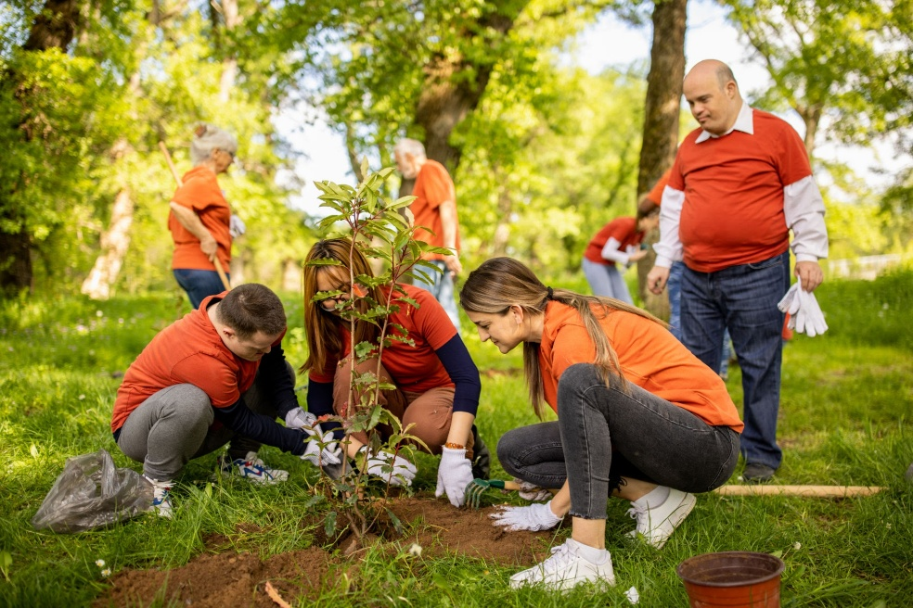
Level of effort high
Bloom’s create
Concept/Skill Writing
Chapter Picture composition

Criteria | Excellent (3 marks) | Good (2 marks) | Needs Improvement (1 mark)
Content / Relevance | All key elements of the picture are described; ideas are fully relevant to the topic | Most key elements described; ideas mostly relevant | Few elements described; ideas not very relevant
Organisation / Coherence | Ideas are logically organised with a clear beginning, middle and end | Ideas somewhat organised; some jumps or gaps | Ideas poorly organised; no clear sequence
Creativity / Imagination | Highly creative; shows originality and imagination in interpretation | Some creativity; interpretation is interesting | Little or no creativity; plain description
Language / Vocabulary | Uses rich vocabulary and varied sentence structures; language is precise and expressive | Uses appropriate vocabulary; sentences mostly correct | Limited vocabulary; simple or repetitive sentences
Grammar / Accuracy | No or very few grammatical, punctuation, or spelling errors | Minor grammatical or spelling errors; meaning still clear | Frequent grammatical or spelling errors; meaning affected

3. | Look at the given picture. Write a story in 120 words or more. (15M)
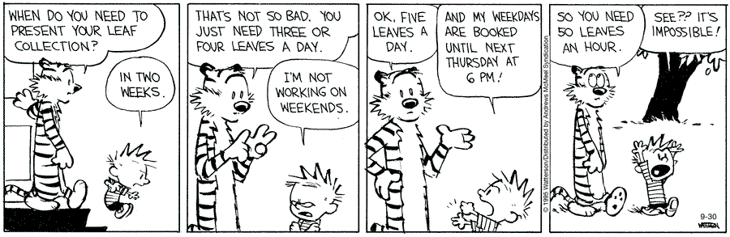

Source: Calvin and Hobbes
Level of effort high
Bloom’s create
Concept/Skill Writing
Chapter Story writing
Criteria | Excellent (3 marks) | Good (2 marks) | Needs Improvement (1 mark)
Content / Relevance | All key elements of the picture are described; ideas are fully relevant to the topic | Most key elements described; ideas mostly relevant | Few elements described; ideas not very relevant
Organisation / Coherence | Ideas are logically organised with a clear beginning, middle and end | Ideas somewhat organised; some jumps or gaps | Ideas poorly organised; no clear sequence
Creativity / Imagination | Highly creative; shows originality and imagination in interpretation | Some creativity; interpretation is interesting | Little or no creativity; plain description
Language / Vocabulary | Uses rich vocabulary and varied sentence structures; language is precise and expressive | Uses appropriate vocabulary; sentences mostly correct | Limited vocabulary; simple or repetitive sentences
Grammar / Accuracy | No or very few grammatical, punctuation, or spelling errors | Minor grammatical or spelling errors; meaning still clear | Frequent grammatical or spelling errors; meaning affected

 | Section E: Grammar (15M)
 | Choose the correct option to complete the statement.
4. | The Paris Climate Agreement ___ in 2016 to combat global warming.  a) was signed  b) signed  c) is signed  d) had signed
Answer: A
Level of effort moderate
Bloom’s application
Concept/Skill Grammar
Chapter Tenses

5. | Researchers ___ groundbreaking discoveries about Mars' atmosphere last month.  a) announce  b) announced  c) announces  d) announcing
Answer: B
Level of effort moderate
Bloom’s application
Concept/Skill Grammar
Chapter Tenses

6. | Artificial intelligence is becoming ___ at diagnosing diseases than humans.  a) more accurate  b) most accurate  c) accurater  d) accurate
Answer: A
Level of effort moderate
Bloom’s application
Concept/Skill Grammar
Chapter degrees of comparison

7. | The Pacific Ocean is ___ than the Atlantic Ocean.  a) more deep  b) deeper  c) deepest  d) most deep
Answer: B
Level of effort moderate
Bloom’s application
Concept/Skill Grammar
Chapter degrees of comparison
8. | To enter the laboratory, students ___ wear protective goggles.  a) must  b) may  c) could  d) might
Answer: A
Level of effort moderate
Bloom’s application
Concept/Skill Grammar
Chapter modals

9. | You ___ try updating the software if your computer crashes frequently.  a) should  b) can  c) would  d) might
Answer: A
Level of effort moderate
Bloom’s application
Concept/Skill Grammar
Chapter modals
10. | There are ___ students in the robotics club this semester.  a) much  b) many  c) little  d) a few
Answer: B
Level of effort moderate
Bloom’s application
Concept/Skill Grammar
Chapter determiners

11. | ___ information about the event is available on the website.  a) Many  b) Few  c) Some  d) Several
Answer: C
Level of effort moderate
Bloom’s application
Concept/Skill Grammar
Chapter Determiners

12. | The cybersecurity workshop will be held ___ March 15th.  a) at  b) on  c) in  d) by
Answer: B
Level of effort moderate
Bloom’s application
Concept/Skill Grammar
Chapter prepositions

13. | The hikers walked cautiously ___ the icy mountain path.  a) across  b) through  c) along  d) into
Answer: C
Level of effort moderate
Bloom’s application
Concept/Skill Grammar
Chapter prepositions
14. | The global climate summit will commence ___ December 5th.  a) on  b) at  c) in  d) by
Answer: A
Level of effort moderate
Bloom’s application
Concept/Skill Grammar
Chapter prepositions
15. | The research team placed the sensors ___ the ocean floor.  a) into  b) on  c) at  d) under
Answer: B
Level of effort moderate
Bloom’s application
Concept/Skill Grammar
Chapter prepositions
16. | By 2030, renewable energy sources ___ 40% of global electricity.  a) will generate  b) generated  c) generates  d) generating
Answer: A
Level of effort moderate
Bloom’s application
Concept/Skill Grammar
Chapter tenses
17. | The archaeologists ___ ancient artifacts in the valley last week.  a) discover  b) discovered  c) discovers  d) discovering
Answer: B
Level of effort moderate
Bloom’s application
Concept/Skill Grammar
Chapter TENSES
18. | Solar energy is ___ to implement in rural areas than nuclear power.  a) easier  b) easiest  c) more easy  d) most easy
Answer: A
Level of effort moderate
Bloom’s application
Concept/Skill Grammar
Chapter degrees of comparison
Part B (15M)
Transform the sentences as instructed.
19. | Employees must attend the cybersecurity workshop. (Rewrite using ‘are required to’)
Answer: Employees are required to attend the cybersecurity workshop.
Level of effort moderate
Bloom’s application
Concept/Skill Grammar
Chapter modals
20. | The Global Trade Summit will open next week. (Rewrite the sentence using a past-time expression.)
Answer: The Global Trade Summit opened last week.
Level of effort moderate
Bloom’s application
Concept/Skill Grammar
Chapter Tenses
21. | Citizens must vote responsibly in a democracy. (Rewrite using ‘should’)
Answer: Citizens should vote responsibly in a democracy.
Level of effort moderate
Bloom’s application
Concept/Skill Grammar
Chapter Modals
22. | There are some historical monuments in this city. (Rewrite the sentence using “any.”)
Answer: There aren’t any historical monuments in this city anymore.
Level of effort moderate
Bloom’s application
Concept/Skill Grammar
Chapter Determiners
23. | The plane flew under the clouds. (Rewrite the sentence using the preposition “over.”)
Answer: The plane flew over the clouds.
Level of effort moderate
Bloom’s application
Concept/Skill Grammar
Chapter Prepositions
24. | Finally, the project was completed after months of work. (Rewrite the sentence using “at last.”)
Answer: At last, the project was completed after months of work.
Level of effort moderate
Bloom’s application
Concept/Skill Grammar
Chapter Sequencing
25. | Doctors can detect heart problems using new technology. (Rewrite the sentence using past-time modal.)
Answer: Years ago, doctors could detect heart problems only with stethoscopes.
The Annual Book Fair opens in December. (Rewrite the sentence to indicate future time.)
Level of effort moderate
Bloom’s application
Concept/Skill Grammar
Chapter Modals
26. | The Annual Book Fair opens in December. (Rewrite the sentence to indicate future time.)
Answer: The Annual Book Fair will open in December next year.
Level of effort moderate
Bloom’s application
Concept/Skill Grammar
Chapter Tenses
27. | This smartphone is more advanced than the previous model. (Transform using the superlative adjective.)
Answer: This is the most advanced smartphone.
Level of effort moderate
Bloom’s application
Concept/Skill Grammar
Chapter Degrees of comparison
28. | The World Health Organisation conducts health drives every year. (Rewrite the sentence using a past-time expression.)
Answer: The World Health Organisation conducted a health drive last year.
Level of effort moderate
Bloom’s application
Concept/Skill Grammar
Chapter Tenses
29. | The cat slept under the bed. (Rewrite the sentence using a preposition of place.)
Answer: The cat slept near the bed.
Level of effort moderate
Bloom’s application
Concept/Skill Grammar
Chapter Prepositions
30. | There are some fresh fruits in the basket. (Rewrite the sentence using a negative determiner.)
Answer: There aren’t any fresh fruits in the basket.
Level of effort moderate
Bloom’s application
Concept/Skill Grammar
Chapter Determiners
31. | Few students submitted their assignments on time. (Rewrite the sentence using a comparative determiner.)
Answer: More students submitted their assignments on time this week.
Level of effort moderate
Bloom’s application
Concept/Skill Grammar
Chapter Degrees of comparison and determiners
32. | The lecture is scheduled in the auditorium. (Rewrite the sentence using a preposition of place.)
Answer: The lecture is scheduled at the auditorium.
Level of effort moderate
Bloom’s application
Concept/Skill Grammar
Chapter Prepositions
33. | Children played ______ the park in the evening. (Choose the correct preposition – across / at / in / over)
Answer: in
Level of effort moderate
Bloom’s application
Concept/Skill Grammar
Chapter Prepositions

